simlogical.com

Tutorial for Creating an at Home School and Orphanage

The Halliwell Orphanage Manor of Education.

Mods Needed:
- Simlogical (simlogical.com)
  - Simlogical prisoners bunk beds, top and bottom
  - Home Worktable and Workbook (substitute the ijHomeworkPlace for the Table if you don’t want the desk)
  - Pupil Token
  - School Bell
  - School Changer (Under Learning, Schoolwork)
  - Flexi School mod
  - Crowd Controller
  - Class Controller
  - Simlogical Classroom Door

- Simlogical (simlogical.com)
a. Table and Counter controller
b. Merola’s Multi Painting also Merola’s Mind Control Mirror
c. Locking doors
•••optional•••
- Christianlov
  - AinO NPC stove
  - Smart Fridge
  - Alarm Clock

- PC Sims (these are located at the Graveyard)
  - Katy’s Badges University Stand
  - School Meal Buffet

- Inteenimator
  - TwoJeffs SmartBeds mod

- At the age of 55, Mother Halliwell retired from her job with the Pleasantville Child Services Division, feeling that the agency didn’t properly serve the needy children of the town. With all of the bureaucratic red tape, the long adoption wait times, and the systemic pilfering of agency monies and constant in fighting, she had had it with the PCSD. On July 4, 2007, after celebrating at her retirement party with co-workers on Independence Day, she took her savings and purchased a 150-year-old Victorian house on the outskirts of town and opened the Halliwell Orphanage Manor of Education.
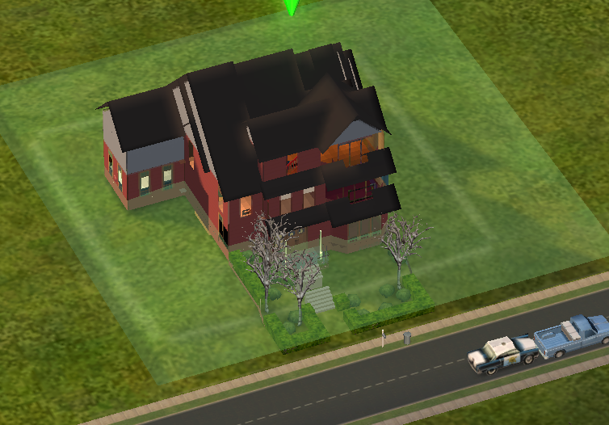

- In preparation for her 12-bed orphanage, she ordered items from her Simlogical catalogue. She purchased prisoner bunk beds (lol, it may only be funny to me, smirk), both tops and bottoms. She also purchased a Simlogical Door Mod so that she could have a boys’ dorm and bathroom, and a girls’ dorm and bathroom. (These have a Gender option!)

- For her classroom, she:
  - Used the Classroom doors to keep students in the classroom
  - Placed the School Changer on a wall and changed the school to Flexi for All Children
  - Placed the School Bell, Classroom Controller, and Crowd Controller on the walls.
  - Placed the pencil (ijHomeworkPlace) on students’ desks.
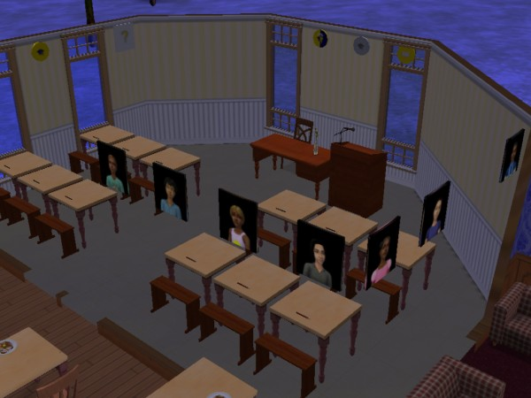

- One by one, the lost neighborhood children found their way to the H.O.M.E.
(In order to get children in the orphanage, I moved in Townies and Downtownies, then turned them into children. I used the Insimenator to Age down my Sims. This way, all the kids had different last names. There are other ways to get a group of sims with different last names living together, but this seemed less complicated to me.)

- Using the Classroom Controller, she assigned herself as teacher. She decided that the students would be in class for both the morning and afternoon sessions, and would complete Gradework. Since she had plans to eventually expand the Orphanage, she set this class as Class 1.
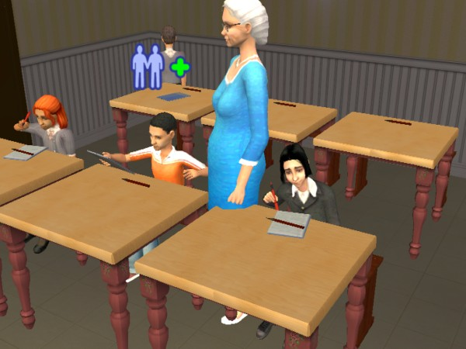
- Mother Halliwell assigned each sim child a token so that it would be easier to remember his/her face and name.
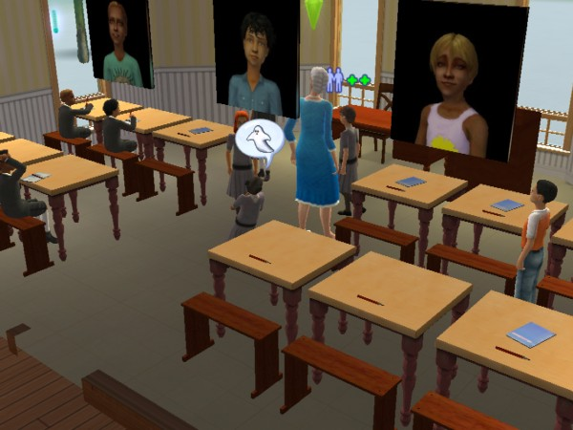

In the Kitchen, she set up the AinO Stove and Smart Fridge (by Christianlov), and set up dining tables and chairs. She used the Simlogical table and counter controller to only allow eating in the dining hall.
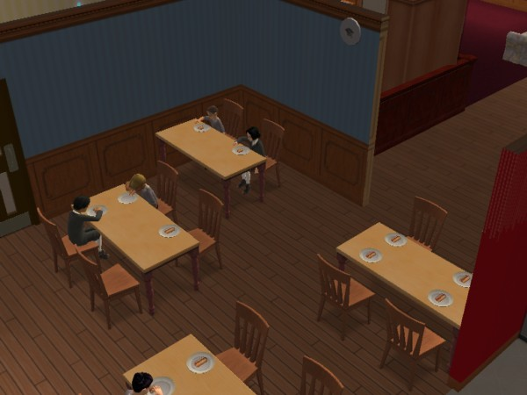

- Upstairs, she organized the dormitories into girls and boys. There are three sets of bunk beds in each room. As you can see, there’s room to grow.
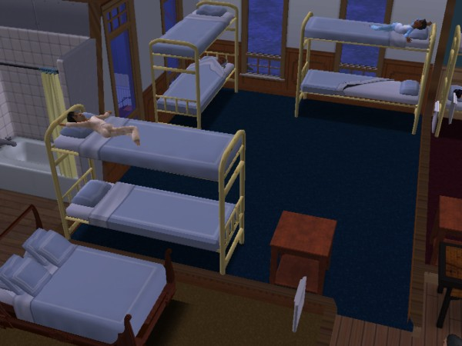

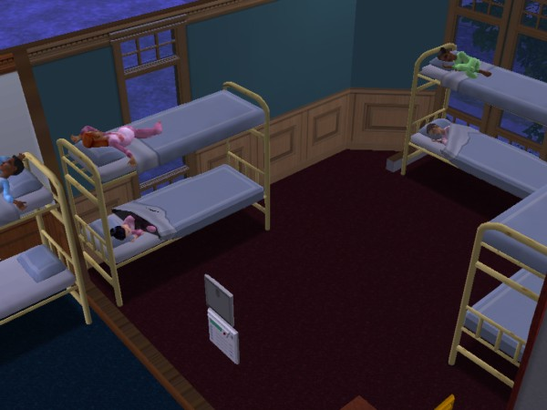
- After supper, she takes time to paint portraits of each of the children. On adoption day, prospective parents are invited to the orphanage (using the Simlogical transporter) to meet an orphan. If the child and the prospective family get along, the parents purchase a picture of a child, and if their application goes through, the child is moved into their new home (using the transporter). (I also use the Simwardrobe Customer Limit Adjuster so that it minimizes the number of shoppers.)
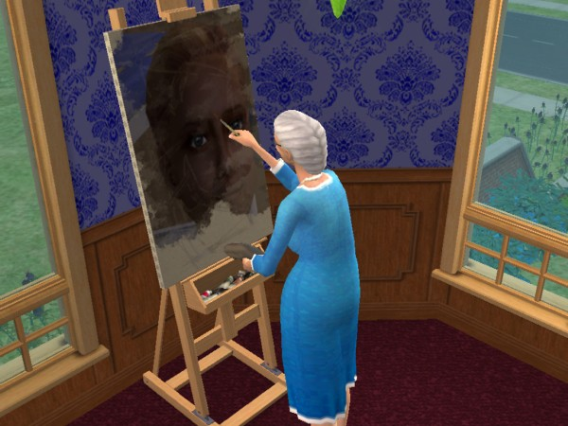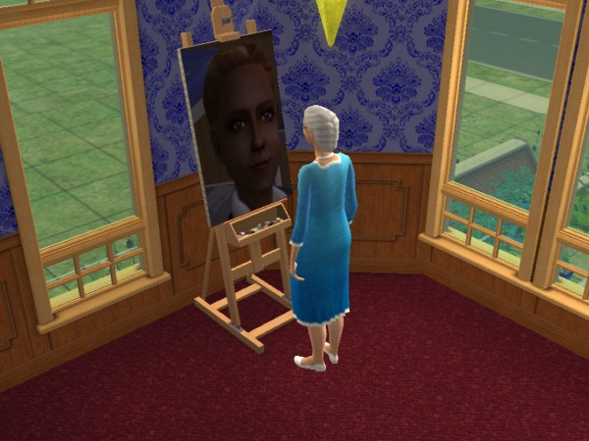

In game pics:

- Matthew Smith has lived at the H.O.M.E. for a year. The PCSD bounced him around from foster home to foster home, but Matthew never felt comfortable and continuously caused much trouble. The HOME is his last chance to find a compatible family. The Griffins have always wanted a family, but Mr. Griffin recently learned that his sperm count was rather low. They tried unsuccessfully for three years to conceive, with no luck. After much discussion and prayer, they applied for adoption papers. Today is the day they visit the orphanage.

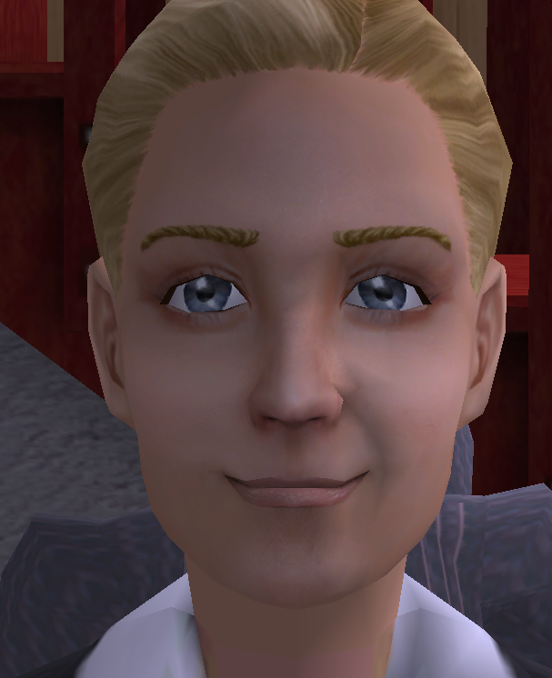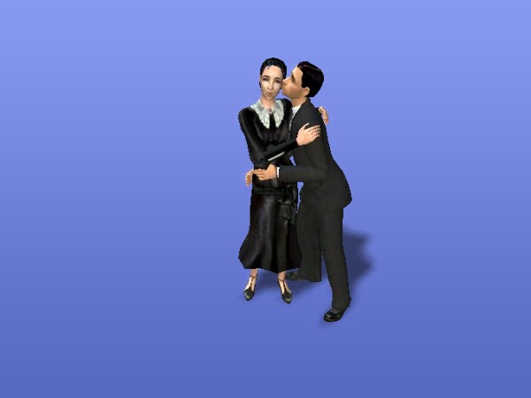

  - The Griffins meet Matthew and spend time with him. It seems that everyone is getting along.

Mr. Griffin meets Mother Halliwell…
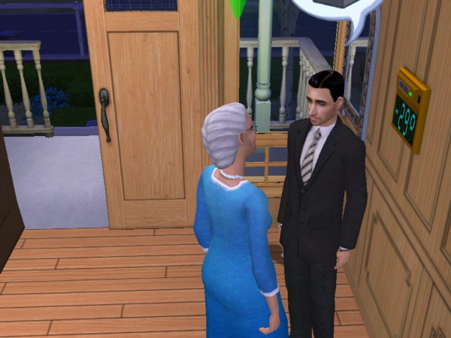

The Griffins share interests with Matthew…
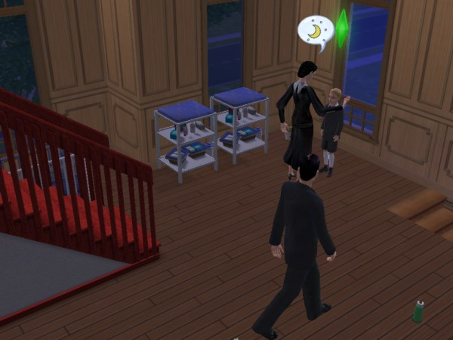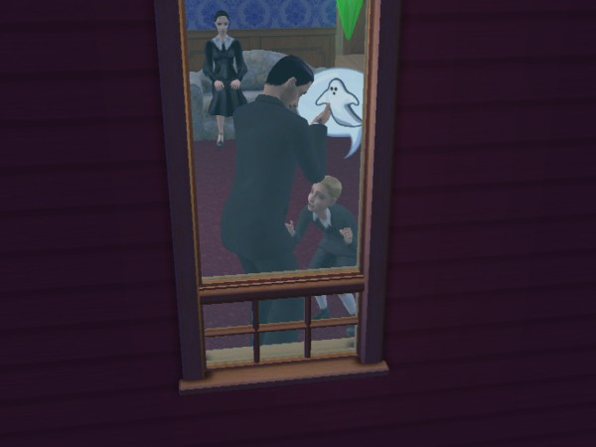

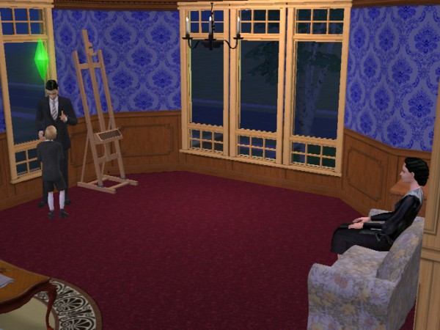

Mother Halliwell conducts an exit interview with the Griffins…
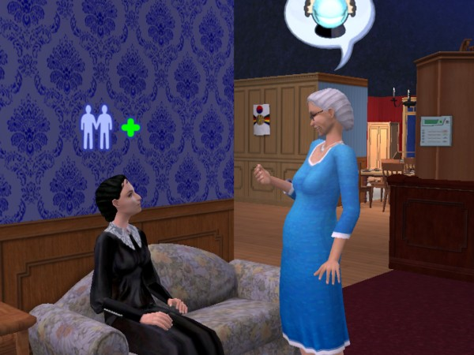

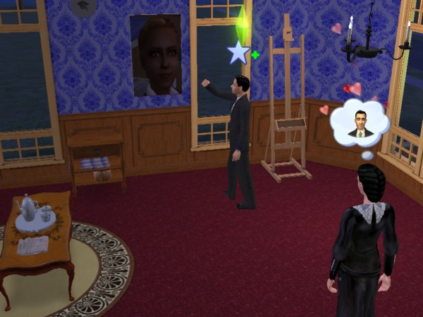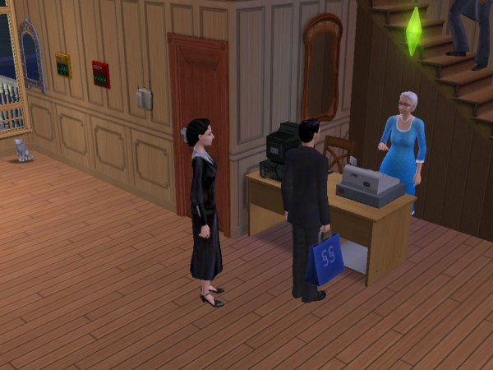

Mother Halliwell types up adoption papers (using Monique’s computer at MTS2).
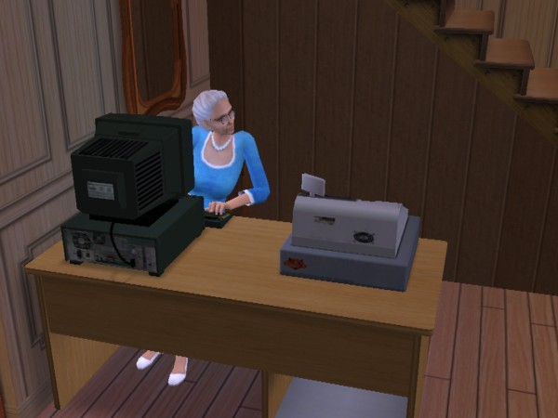

(An example of children listening to Mother Halliwell lecture using Katy_76’s lecture podium.)
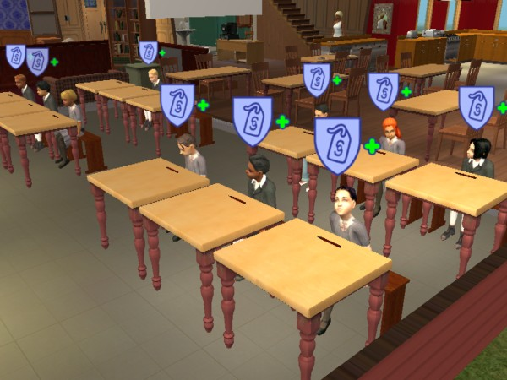

That’s It.

